NAME: RAJA RAYYAN AMEER
REG. NO.: 23-CP-25
SECTION: ALPHA
SUBJECT: DATABASE MANAGEMENT SYSTEM
DEPARTMENT: COMPUTER ENGINEERING
TEACHER: SIR SHAHID
LAB 5
Task 1: Create the Customer Table with Primary Key. Define the Customer table with:
- customer_id (Primary Key)
- name (NOT NULL)
- email (UNIQUE, NOT NULL)
- phone
Query:
CREATE TABLE Customer (
customer_id INT PRIMARY KEY,
name VARCHAR(100) NOT NULL,
email VARCHAR(100) NOT NULL UNIQUE,
phone VARCHAR(20)
);
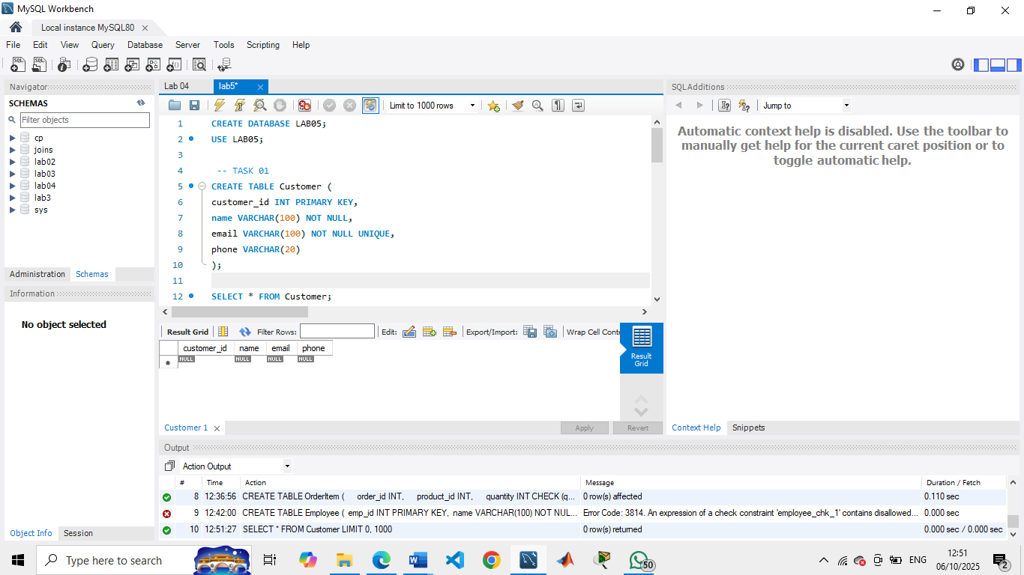
Task 2: Create the Product Table with a CHECK Constraint on Price. Define the Product table with:
- product_id (Primary Key)
- product_name (NOT NULL)
- price (must be greater than 0)
- stock (default 0)
Query:
CREATE TABLE Product (
product_id INT PRIMARY KEY,
product_name VARCHAR(100) NOT NULL,
price DECIMAL(10,2) CHECK (price > 0),
stock INT DEFAULT 0
);
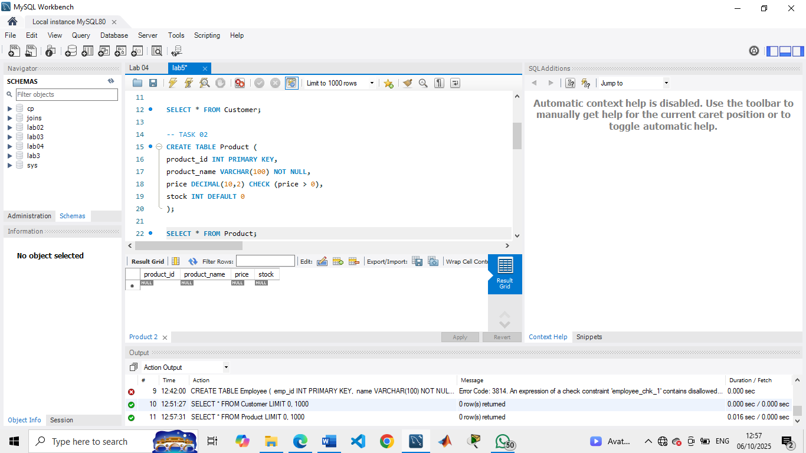
Task 3: Create the Orders Table with a Foreign Key. Create the Orders table with:
- order_id (Primary Key)
- order_date
- customer_id (FK → Customer)
Query:
CREATE TABLE Orders (
order_id INT PRIMARY KEY,
order_date DATE,
customer_id INT,
FOREIGN KEY (customer_id) REFERENCES Customer(customer_id)
);
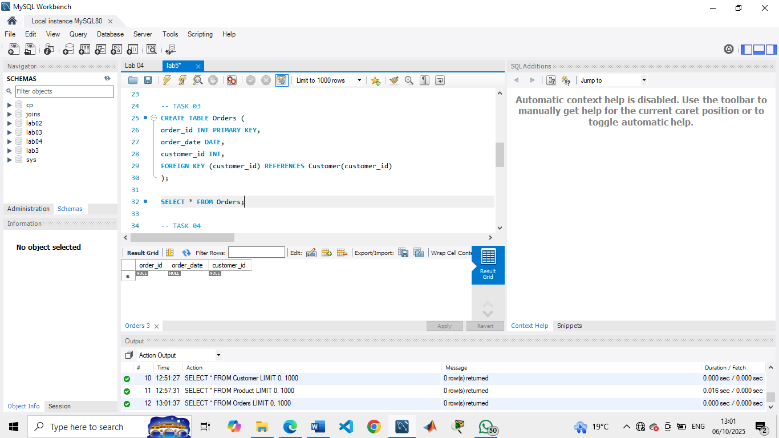
Task 4: Add Cascading Delete & Update Rules. Alter the Orders table so that:
- If a customer is deleted, their orders are also deleted.
- If a customer ID changes, it updates in Orders.
Query:
ALTER TABLE Orders
DROP FOREIGN KEY Orders_ibfk_1;

ALTER TABLE Orders
ADD CONSTRAINT fk_customer
FOREIGN KEY (customer_id) REFERENCES Customer(customer_id)
ON DELETE CASCADE
ON UPDATE CASCADE;
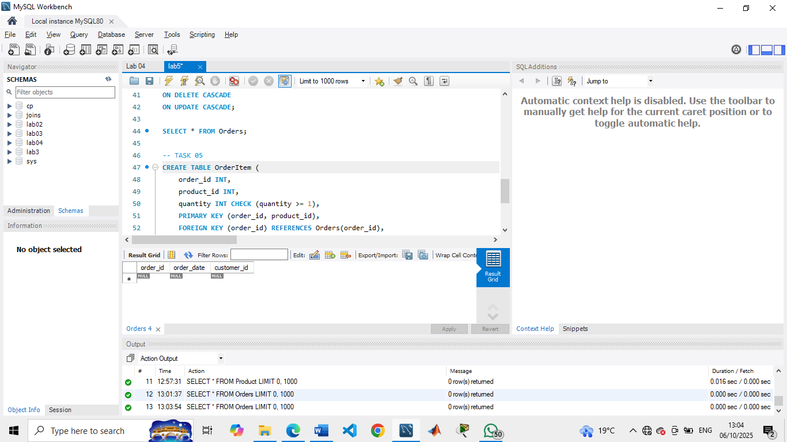
Task 5: Create the OrderItem Table with Composite Primary Key. Define the OrderItem table with:
- order_id (FK → Orders)
- product_id (FK → Product)
- quantity (must be ≥ 1)
Query:
CREATE TABLE OrderItem (
order_id INT,
product_id INT,
quantity INT CHECK (quantity >= 1),
PRIMARY KEY (order_id, product_id),
FOREIGN KEY (order_id) REFERENCES Orders(order_id),
FOREIGN KEY (product_id) REFERENCES Product(product_id)
);
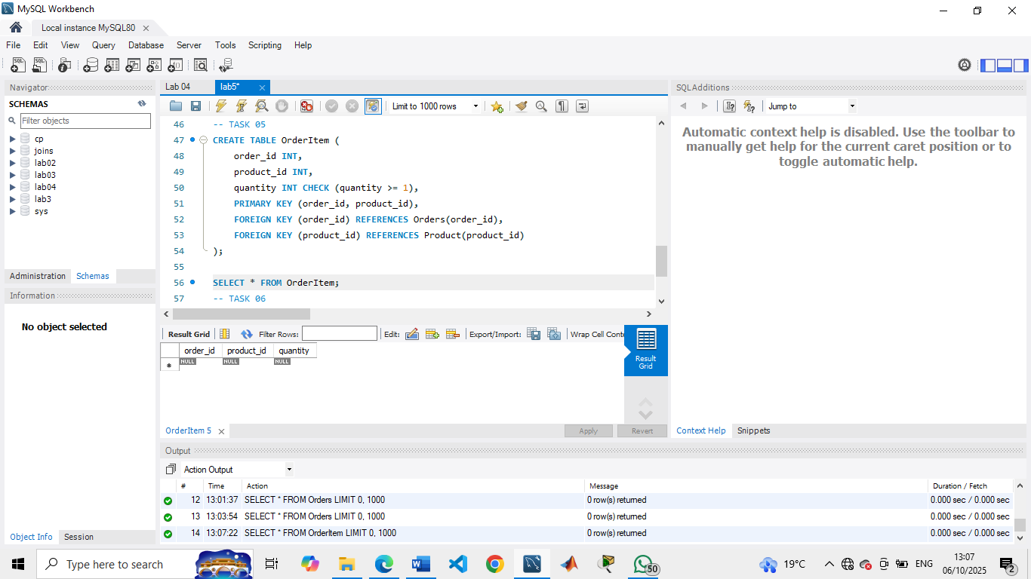
Task 6: Create the Employee Table with Role Restriction. Define Employee table with:
- emp_id (Primary Key)
- name (NOT NULL)
- role (must be either 'Manager', 'Cashier', 'Stocker')
- hire_date (cannot be future)

Query:
CREATE TABLE Employee (
emp_id INT PRIMARY KEY,
name VARCHAR(100) NOT NULL,
role ENUM('Manager','Cashier','Stocker'),
hire_date DATE DEFAULT (CURRENT_DATE)
);
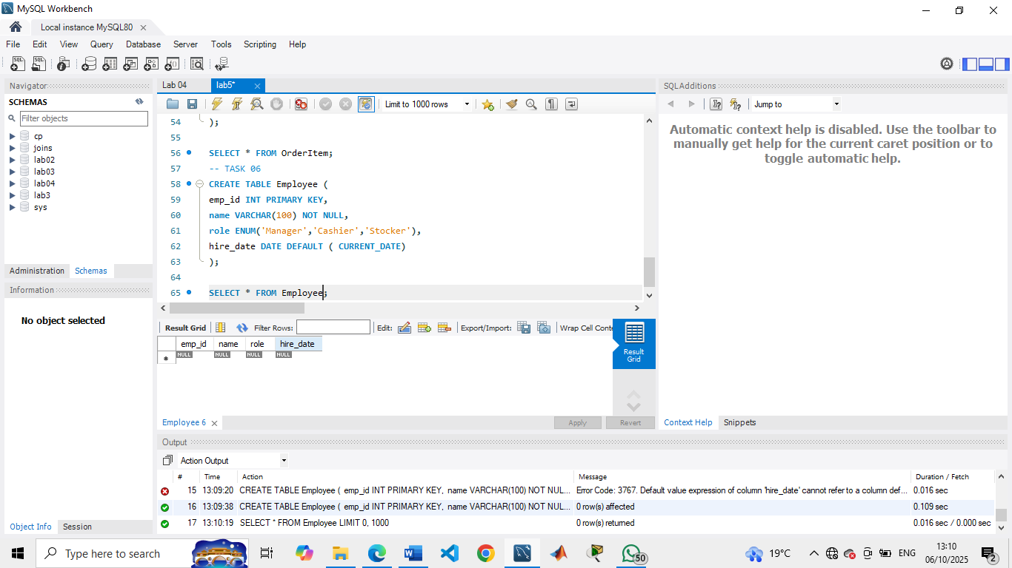
Task 7: Add a status column to Orders with default 'Pending'.
Query:
ALTER TABLE Orders
ADD status VARCHAR(20) DEFAULT 'Pending';
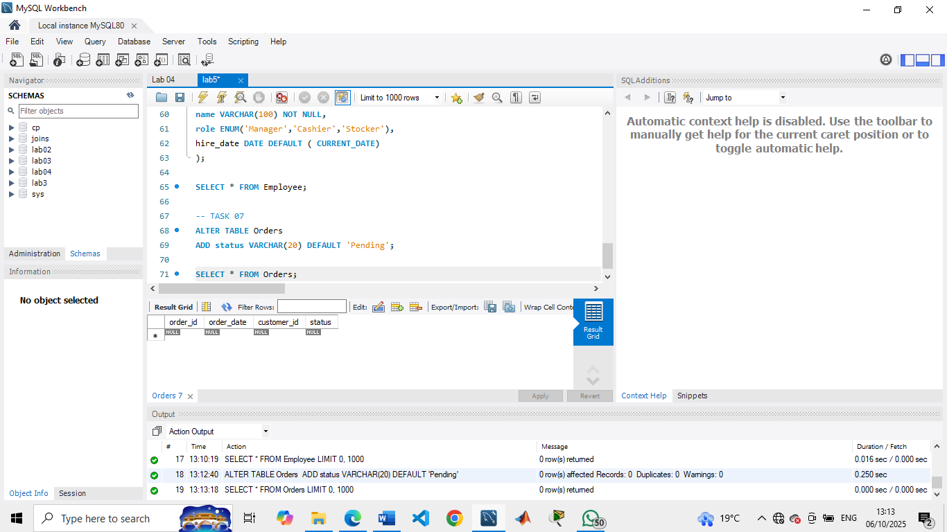
Task 8: Inspect All Tables and Constraints. Use MySQL commands to check table structures and constraints.
Query:
SHOW TABLES;
DESCRIBE Orders;
SHOW CREATE TABLE OrderItem;
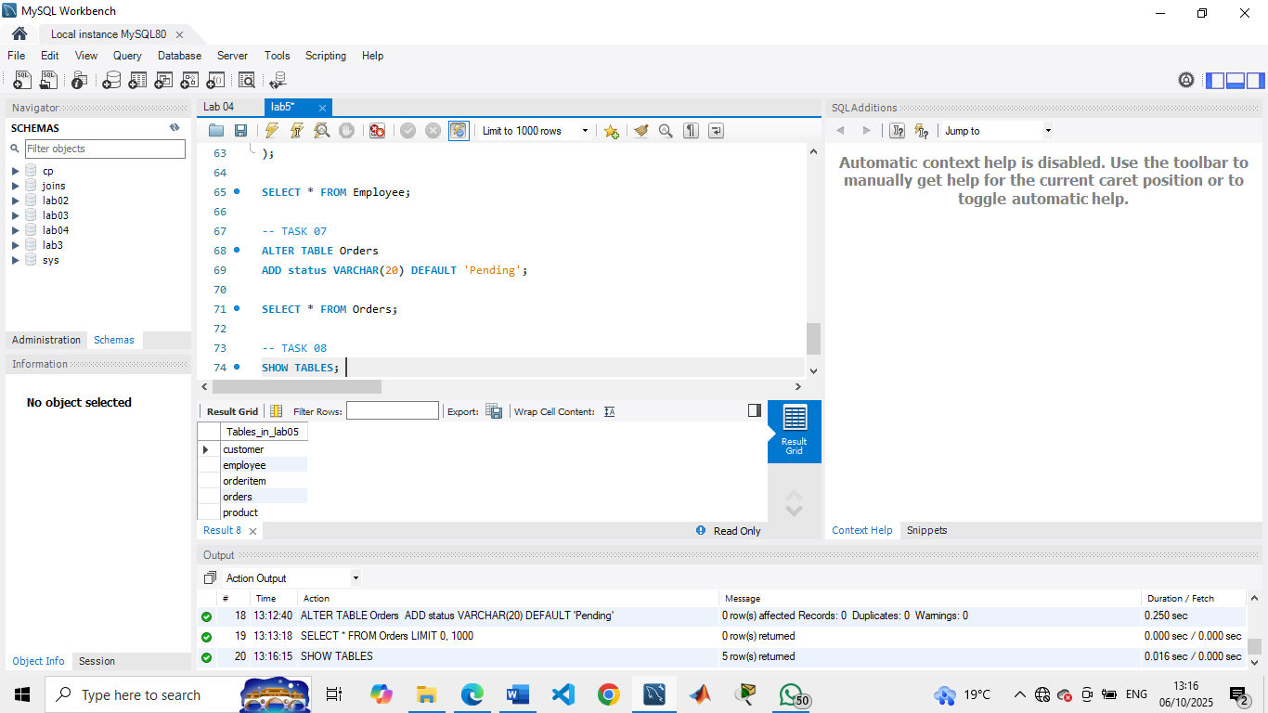
Task 9: Test Constraint Enforcement Test Constraint Enforcement.
Query:
INSERT INTO Customer VALUES (1, 'Alice', 'alice@example.com', '12345');
INSERT INTO Customer VALUES (2, 'Bob', 'alice@example.com', '67890');
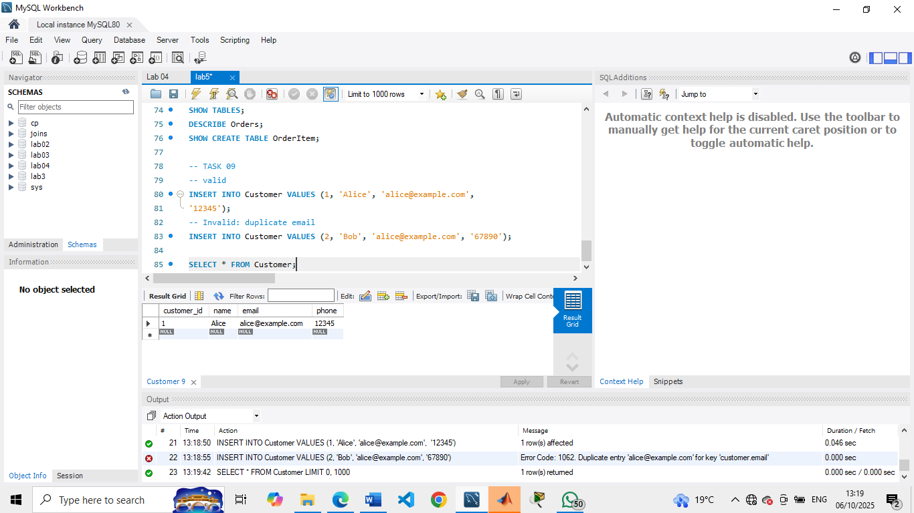
Task 10: Modify Constraints on Existing Tables.
Query:
ALTER TABLE Orders
MODIFY status VARCHAR(20) NOT NULL DEFAULT 'Pending';
ALTER TABLE Orders
CHANGE status order_status VARCHAR(20) NOT NULL;
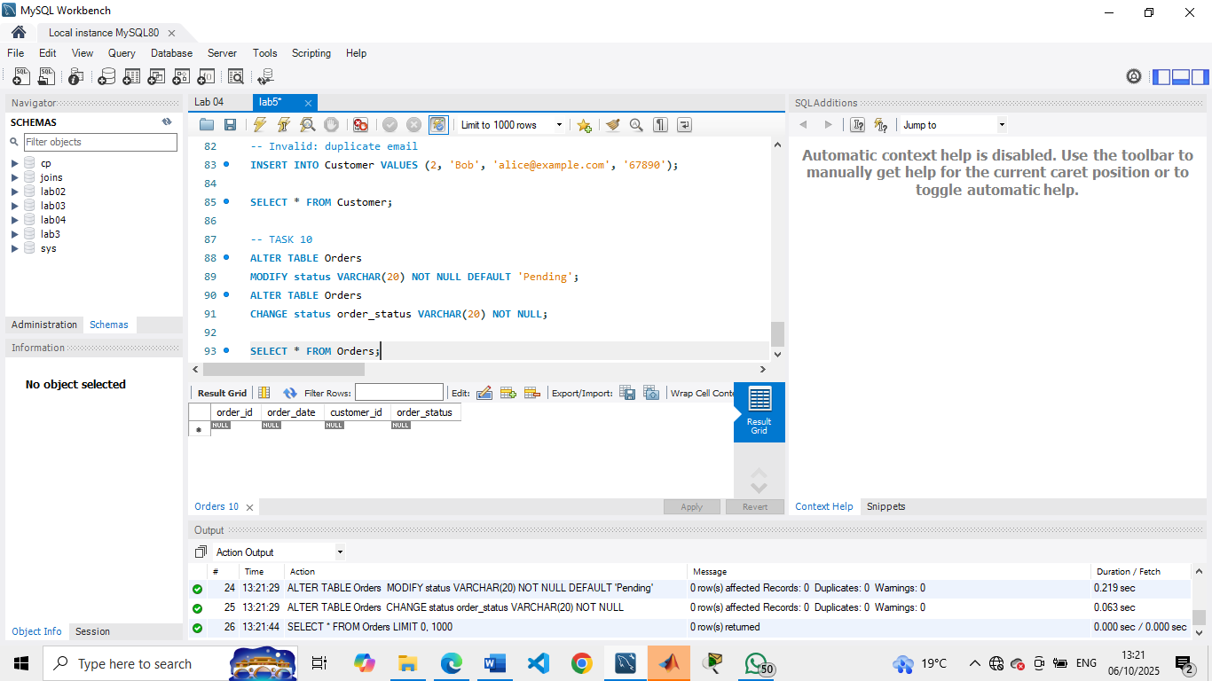
Challenge 1: Create a Supplier table with supplier_id (PK) and link it to Product using a foreign
key with ON DELETE SET NULL.
Query:
CREATE TABLE SUPPLIER (
SUP_ID INT PRIMARY KEY,
SUP_NAME VARCHAR(20) NOT NULL
);
ALTER TABLE Product ADD COLUMN supplier_id INT;
SELECT *FROM Product;

ALTER TABLE Product ADD CONSTRAINT fk_supplier
FOREIGN KEY (supplier_id) REFERENCES Supplier(supplier_id)
ON DELETE SET NULL;

SELECT *FROM Product;
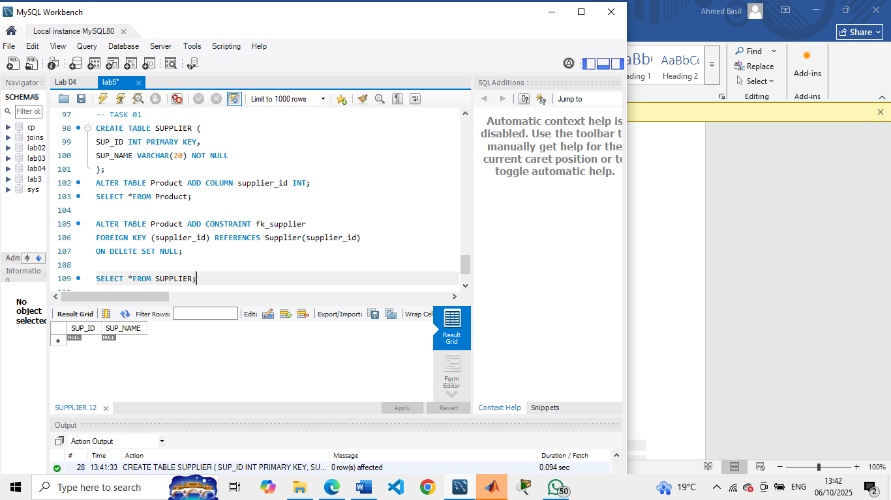
Challenge 2: Add a CHECK constraint to ensure stock in Product is never negative.
Query:
ALTER TABLE Product ADD CONSTRAINT check_neg CHECK (stock>=0);
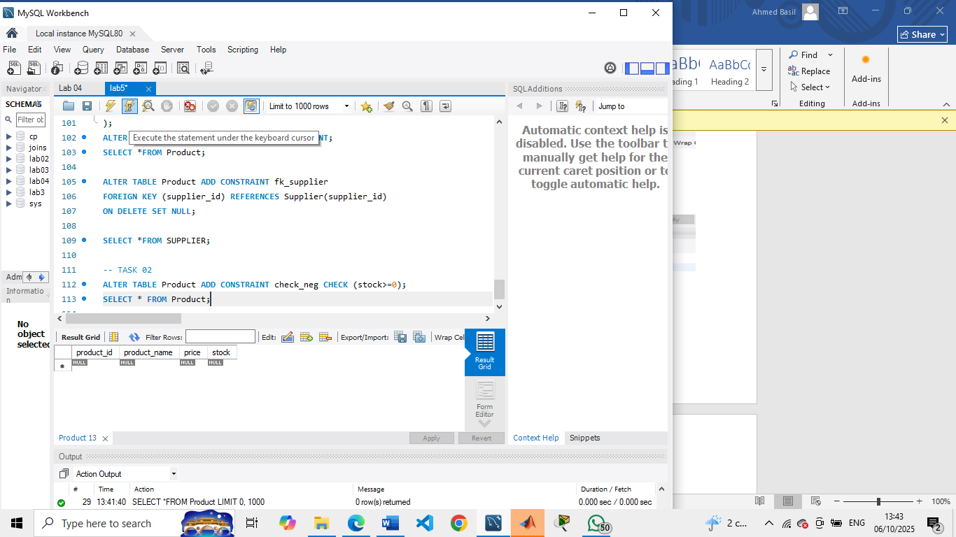
Challenge 3: Enforce that each OrderItem quantity must be ≤ available stock in Product.
Query:
DELIMITER $$

CREATE TRIGGER check_quantity_before_insert
BEFORE INSERT ON OrderItem
FOR EACH ROW
BEGIN
DECLARE available_stock INT;

SELECT stock INTO available_stock
FROM Product
WHERE product_id = NEW.product_id;

IF NEW.quantity > available_stock THEN
SIGNAL SQLSTATE '45000'
SET MESSAGE_TEXT = 'Order quantity exceeds available stock';
END IF;
END $$
Challenge 4: Rename the hire_date column in Employee to date_hired and keep the date constraint intact.
Query:
ALTER TABLE Employee
RENAME COLUMN hire_date TO date_hired;
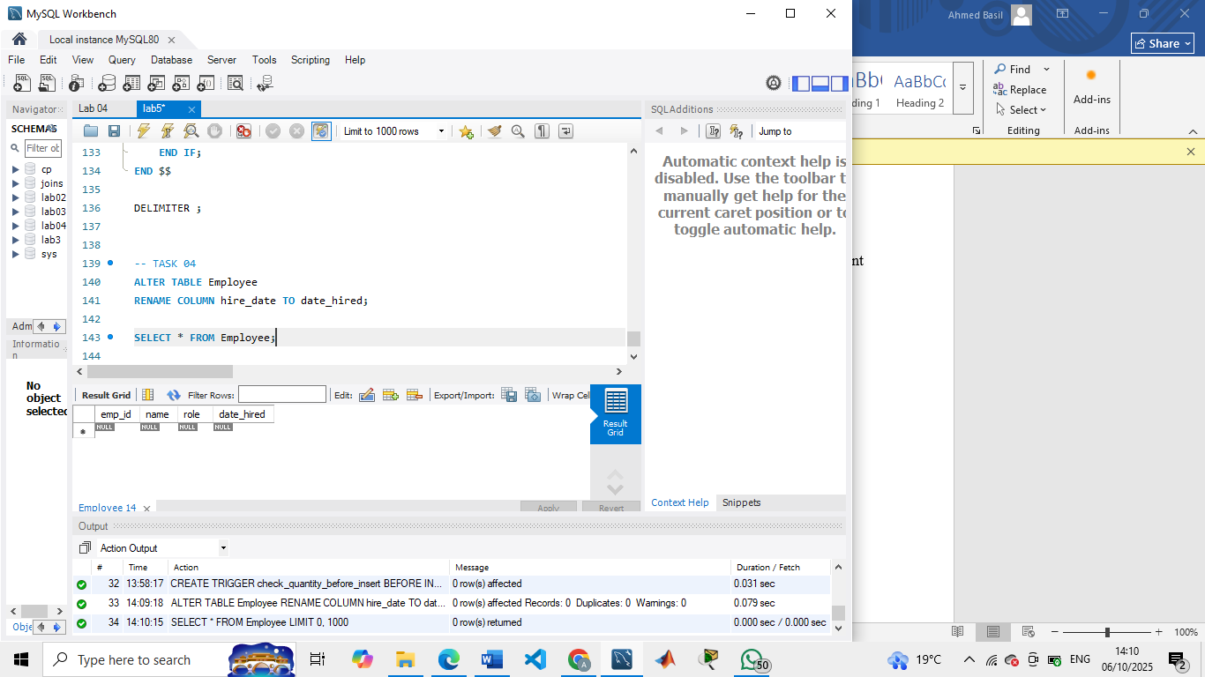
Challenge 5: Drop the foreign key in OrderItem referencing Orders and recreate it with ON DELETE CASCADE.
Query:
ALTER TABLE OrderItem
DROP FOREIGN KEY fk_orderitem_orders;

ALTER TABLE OrderItem
ADD CONSTRAINT fk_orderitem_orders
FOREIGN KEY (order_id) REFERENCES Orders(order_id)
ON DELETE CASCADE;
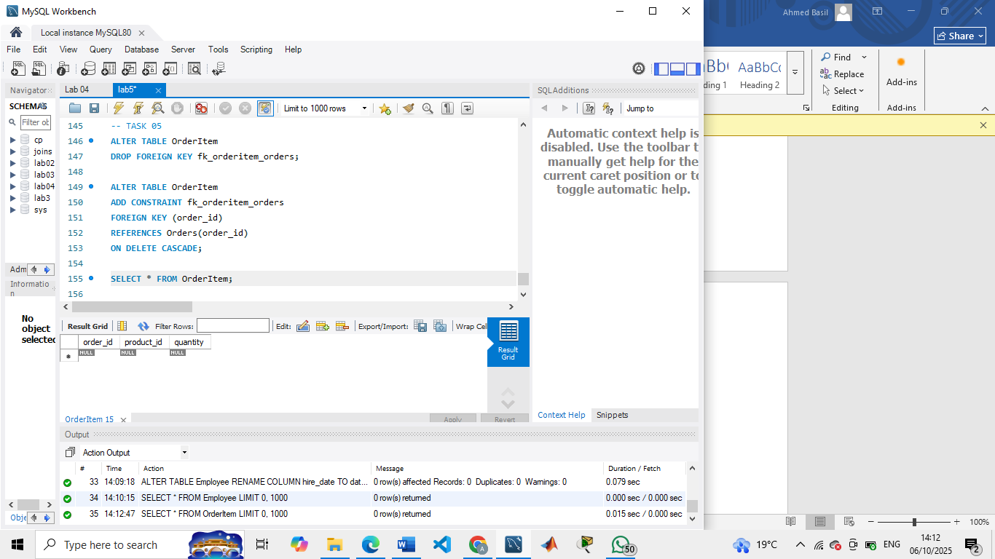
THE END

